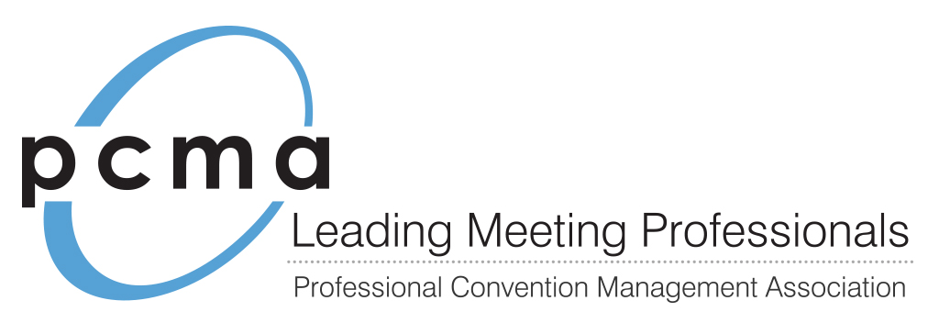

[insert date]

Dear [insert name],

I would like to request approval to join PCMA, the Professional Convention Management Association and its [insert location] Chapter.

Established in 1957, PCMA is the leading professional association for meeting and event professionals with 17 chapters in the United States, Canada and Mexico.

In addition to PCMA’s two national events, Convening Leaders and the Education Conference, I would have access to free regional educational events. Sample topics include:

* Trends in Technology for Meetings (And Hands-on Experience)
* Innovative Idea Exchanges in a Roundtable Format
* Customer Service Training from Worldwide Leaders Such as Disney Institute®
* Creating Engaging and Interactive Meetings
* Case Studies from Meetings of All Sizes
* Negotiations and Business Value from a Facility Perspective

I believe that by joining PCMA I can gain the knowledge and connections necessary to make our meetings fresh, keep our attendees engaged and use our budget to its fullest potential.

My individual membership in PCMA will cost [insert cost] per year. They also have alternative options for paying membership dues such as hotel rewards points and scholarships.

Please let me know if I have your approval to proceed or I can provide additional information.

Sincerely,

[insert your name here]